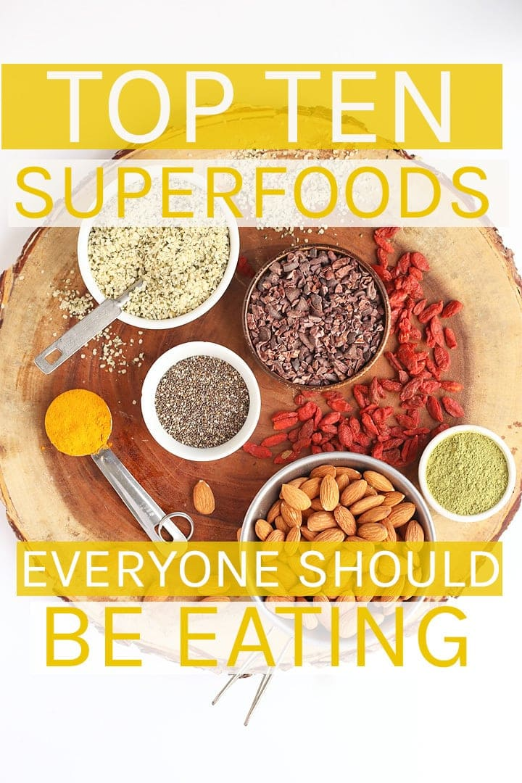

10 SUPERFOODS YOU SHOULD BE EATING

1. CACAO NIBS
Cacao nibs are the seeds from the fruit of the cacao tree – the tree that produces the bean from which we make cocoa and chocolate. Cacao nibs are bold in flavor and slightly bitter in taste. With the perfect crunch, they add wonderful taste and texture (not to mention many health benefits) to cookies, oatmeal, smoothies, and more.
BENEFITS OF CACAO NIBS
- high in antioxidants
- naturally mood boosting
- enhances energy and focus
- great source of fiber, iron, and calcium
- prevents premature aging and promotes skin health
RECIPES WITH CACAO NIBS
- Cacao Goji Berry Power Cookies
- Healthy Chocolate Peanut Butter Steal Cut Oats
- Chocolate Hazelnut Hemp Smoothie Bowl

2. HEMP HEARTS
Hemp hearts are the shelled seeds of the industrial hemp plant (related to cannabis plant). They have an earthy nutty flavor and a nice soft crunch. Despite being so small, they are packed with nutrients. So go ahead, sprinkle them on your salads, and dinner bowls.
BENEFITS OF HEMP HEARTS
- Provides a complete protein
- Promotes weight loss
- Hair, skin, and nail health
- Filled with Omega-3s
- A great source of natural energy
RECIPES WITH HEMP HEARTS
- Vegan Hemp Parmesan Cheese
- Tofu Kale Breakfast Bowl
- Kale Caesar Salad

3. TURMERIC
Turmeric is a bright yellow spice that comes from the roots of a plant in the ginger family. Best known for its anti-inflammatory effects, turmeric is one of the oldest herbal medicine. Its subtle flavor makes it easy to add to your soups, scrambles, and nut-cheeses to enhance color and provide healthful benefits without compromising the flavor.
BENEFITS OF TURMERIC
- Decreases inflammation in vessels, skin, and gut
- Balances mood
- Boosts skin health
- Alleviates joint pains
- Promotes brain and heart health
RECIPES WITH TURMERIC
- Golden Chai Lattes
- Red Lentil Curry Soup
- Vegan Cauliflower Queso

4. GOJI BERRIES
Goji berries are an ancient Chinese medical berry that can be eaten raw or dried. They are a great source of important vitamins and minerals such as vitamins A and C, zinc, and iron. Goji berries have a sharp tart flavor making them a great addition to cookies, oatmeal, and granola bars.
BENEFITS OF GOJI BERRIES
- Powerful antioxidant
- Detoxifies the liver
- Boosts fertility
- Improves immunity and fights cancer
- Promotes healthy skin
RECIPES WITH GOJI BERRIES
- Cacao Goji Berry Power Cookies
- Green Power Smoothie
- Grain-Free Superfood Granola Bars

5. QUINOA
Quinoa has been growing in South America for thousands of years, making it one of the oldest superfoods. With a full, nutty flavor and cooking like a grain, quinoa becomes the perfect base for gluten/grain-free bowls and salads. You can also mill the seed into flour which bakes similar to all-purpose flour and makes some of the best gluten-free cookies I’ve ever had.
BENEFITS OF QUINOA
- Aids in weight loss and supports metabolic health
- Supports a healthy heart
- High in protein, fiber, and important vitamins
- Helps control blood sugar and regulate diabetes
- Naturally gluten and grain free for a hearty grain-like substitute.
RECIPES WITH QUINOA
- BBQ Tempeh Quinoa Bowls
- Thai Quinoa Salad with Peanut Sauce
- Salted Chocolate Chip Quinoa Cookies

6. CHIA SEEDS
Chia seeds are the seed of the desert plant, Salvia hispanica, which originated in Central America. Chia seeds are small, adding a tiny crunch and lots of powerful benefits. Add chia seeds to salads, bowls, and smoothies or combine them with liquid to create a naturally gelatinous texture, perfect for chia pudding or an egg replacer.
BENEFITS OF CHIA SEEDS
- Healthy skin and anti-aging properties
- Supports digestive and heart health
- Boosts energy and metabolism
- Great source of Omega-3
- Regulates diabetes
RECIPES WITH CHIA SEEDS
- Matcha Chia Pudding
- Gluten-Free Breakfast Cookies
- Blueberry Coconut Smoothie Bowl

7. KALE
Kale is one of my favorite superfoods. Earthy and slightly bitter, kale grows easily (I’ve got some in my garden right now) and is one of the most versatile dark leafy greens available. You can add kale to stir-fries, sneak it in smoothies, make kale chips, or use it the base of your favorite salad.
BENEFITS OF KALE
- has anti-inflammatory properties
- detoxifies the body
- promotes healthy vision
- provides cancer prevention + heart health
- is PACKED with necessary vitamins and minerals
RECIPES WITH KALE
- Butternut Squash and Kale Lasagna
- Lemon Tahini Kale Salad
- Ginger Mango Green Smoothie

8. MATCHA
Matcha – potent powdered green tea leaves – might be might favorite superfood right now. As I’ve said before, after giving up coffee I started drinking a daily matcha latte. Since doing that I have seen incredible improvements in decreasing stress, better energy, and healthier skin. Wanna try it for yourself? Make your own matcha lattes from home and release the power of matcha!
BENEFITS OF MATCHA
- High in antioxidants
- Reduces stress and enhances calm
- Natural energy and concentration boosters
- Detoxifies the body
- Burns calories and supports weight loss
RECIPES WITH MATCHA
- Pistachio Matcha Chocolate Cups
- Matcha Steel Cut Oats
- Matcha Chia Pudding

9. ALMONDS
The seeds from the fruit of an almond tree, almonds are considered by many the most healthy nut for its dense nutritional values. Earthy, crunchy, and slightly sweet, almonds can be used in both sweet and savory recipes as well as a perfect snack on its own.
BENEFITS OF ALMONDS
- Boost brain health
- Prevents heart disease
- Boosts immune system
- Regulates blood pressure
- Protects against diabetes
RECIPES WITH ALMONDS
- Maple Almond Pretzel Butter
- Vegan Almond Joy Ice Cream
- Mexican Hot Chocolate Coated Almonds

10. BLUEBERRIES
Everyone loves blueberries and fortunately they are one of the best superfoods available! Low in calorie and packed with nutrients, these juicy sweet berries are a superfood you should be adding to your oats, baking in your pasties, and blending in your smoothies.
BENEFITS OF BLUEBERRIES
- High in antioxidants
- Protects against aging and cancer
- Boosts heart health
- Improves brain function and memory
- High in fiber
RECIPES WITH BLUEBERRIES
- Vegan Blueberry Muffins
- Blueberry Coconut Overnight Oats
- Coconut Blueberry Smoothie Bowl

