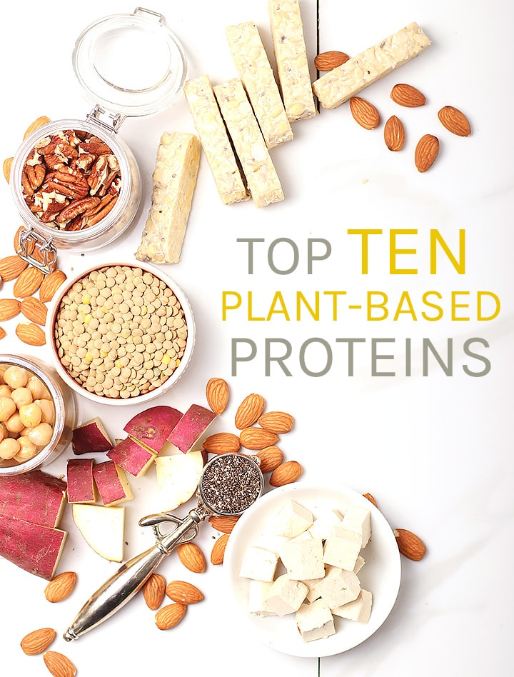

HOW MUCH PROTEIN SHOULD I BE EATING?
Protein is obviously essential for life, but for many years we have had a misrepresentation of how much protein we need to be eating. According to Harvard Medical School, you can figure out how much protein you should be eating by multiplying your weight in pounds by 0.36 or use this online protein calculator. On average this calculates to:
- 56 grams per day for the average sedentary man.
- 46 grams per day for the average sedentary woman.
A very active person, athlete, or pregnant person will need about 50% more. To read more about how much protein we should be eating, this is a helpful article.

VEGAN PROTEIN VS ANIMAL PROTEIN
Not all protein is created equal and I would argue that plant-based protein, as a whole, is much better for your body. A few things to keep in mind when considering plant vs. animal protein:
Is it a complete protein? Generally speaking, animal protein contains the 9 essential amino acids that our bodies need. Not all plant-based protein contains all 9, but that doesn’t mean it’s hard to get what we need from plant-based proteins. (more on that below).
Does it have essential vitamins and nutrients? Animal protein has b12 and that can be hard for vegans to get without taking a supplement. However, plant protein offers much more essential vitamins and nutrients such as phytonutrients and antioxidants. Beyond that, vegan protein is the only protein source that contains fiber, which is necessary for a healthy digestive system.
What else is in my protein? Animal protein does have all essential amino acids and b12 but that’s not all it contains. Animal proteins are often filled with the hormone and antibiotics that were given to the farm animals and are often high in saturated fat and cholesterol, which may be linked to cardiovascular disease. Whereas, vegan protein has zero hormones, antibiotics, or cholesterol and is typically comprised only of heart-healthy fats.

PLANT-BASED COMPLETE PROTEIN FOODS
There are many plant-based proteins that do contain all 9 essential amino acids and others, that when paired together, give you a complete protein. Here are some of my favorite plant-based complete proteins:
- Quinoa
- Buckwheat
- Tofu, Tempeh, and edamame
- Hemp Hearts
- Chia Seeds
- Pumpkin Seeds
- Chickpeas
- Seitan
Also, it’s important to remember than any time a grain (like rice, wheat, or corn) is combined with a legume (like beans, lentils, or peanuts) you have a complete protein. That means a snack like toast and peanut butter, rice and beans, or hummus and pita all contain a complete vegan protein source.

PLANT-BASED PROTEIN SOURCES
Don’t be fooled into thinking that protein needs to come from animals. There are many plant-based protein sources that not only are dense in protein but offer complete proteins with all 9 essential amino acids.

1.CHIA SEEDS
Chia seeds are the seed of the desert plant, Salvia hispanica, which originated in Central America. They are small, adding a tiny crunch and lots of powerful benefits. Add chia seeds to salads, bowls, and smoothies or combine them with liquid to create a naturally gelatinous texture, perfect for chia pudding or an egg replacer.
PROTEIN IN CHIA SEEDS
- A complete protein
- 19% protein or 10 grams in 2 ounces
RECIPES WITH CHIA SEEDS
- Matcha Chia Pudding
- Gluten-Free Breakfast Cookies
- Blueberry Coconut Smoothie Bowl

2. HEMP HEARTS
Hemp hearts are the shelled seeds of the industrial hemp plant (related to the cannabis plant). They have an earthy nutty flavor and a nice soft crunch. Despite being so small, they are packed with nutrients. So go ahead, sprinkle them on your salads, and dinner bowls. Blend them in your smoothies, or add them to your tofu scrambles.
PROTEIN IN HEMP HEARTS
- A complete protein source
- 2 tablespoons have about 11 grams of protein
RECIPES WITH HEMP HEARTS
- Vegan Hemp Parmesan Cheese
- Tofu Kale Breakfast Bowl
- Kale Caesar Salad

3. NUTS AND NUT BUTTERS
Nuts and nut butters are commonly known for being rich in protein. Earthy, crunchy, and slightly sweet, nuts can be used in both sweet and savory recipes as well as a perfect snack on its own. While all nuts contain protein, the most protein-dense nuts are peanuts, almonds, pistachios, cashews, and walnuts.
PROTEIN IN NUTS PER 100g
- Peanuts – 25.8
- Almonds -21.5
- Pistachios – 20.1
- Cashews – 18.2
RECIPES WITH NUTS
- Maple Almond Pretzel Butter
- 4-Ingredient Peanut Butter Cookies
- Thai Salad with Sesame Peanut Sauce

4. QUINOA
Quinoa has been growing in South America for thousands of years, making it one of the oldest forms of complete plant-based proteins. With a full, nutty flavor and cooking like a grain, quinoa becomes the perfect base for gluten/grain-free bowls and salads. You can also mill the seed into flour which bakes similar to all-purpose flour and makes some of the best gluten-free cookies I’ve ever had.
PROTEIN IN QUINOA
- A complete protein source
- Quinoa is 16% protein or 8+ grams per serving
RECIPES WITH QUINOA
- BBQ Tempeh Quinoa Bowls
- Thai Quinoa Salad with Peanut Sauce
- Salted Chocolate Chip Quinoa Cookies

5. WHOLE GRAINS
Whole grains are high in vegan protein on their own but when combined with any legume, a complete protein is formed. Some of my favorite high-protein grains are wild rice, buckwheat, couscous, and oats. 1 serving of overnight oats contains 16.9 grams of protein. Make it Peanut Butter Overnight Oats and you’ve got a complete protein!
PROTEIN IN GRAINS PER CUP
- Amaranth – 26 g
- Wild Rice – 24 g
- Buckwheat – 13.2g
- Oats – 16.9g
RECIPES WITH WHOLE GRAINS
- Garlic Rice Pilaf
- Wild Rice and Pesto Salad
- Shiitake Mushroom and Kale Savory Oats

6. TOFU & TEMPEH
Both tofu and tempeh come from soybeans and provide an excellent source of protein. Tofu has an egg-like consistency and works like a sponge, taking on any flavors it marinates with while tempeh has a hearty nutty flavor and sausage-like texture making it perfect for vegan meatballs or Reuben sandwiches.
PROTEIN PER SERVING
- a complete protein
- Tempeh – 15.4 grams
- Tofu – 10.1 grams
RECIPES WITH TOFU & TEMPEH
- Vegan Tempeh Meatballs
- Broccoli Pepper Stir Fry with Tofu
- Easy Tofu Scramble

7. LENTILS & LEGUMES
Lentils and other legume are protein-packed food that comes in a variety of colors and textures. Some of the most common lentils are red, brown, and green. Red lentils are common in Mediterranean and Indian cooking. They are mostly used in Red Lentil Curries or Red Lentil Soups. Other high-protein legumes are peanuts, peas, and edamame.
PROTEIN IN LENTILS PER CUP (COOKED)
- Red lentils – 18g
- Brown lentils – 24g
- Make up a complete protein when mixed with rice
RECIPES WITH LENTILS
- Moroccan Stuffed Eggplant
- Vegan Meatloaf with Mushrooms and Lentils
- Red Lentil Cauliflower Curry

8. SEITAN
Similar to tofu and tempeh, seitan is a meat substitute that is made from cooked wheat gluten. It is an excellent source of complete protein while offering a chewy, meat-like texture to your favorite comfort foods. Beyond that, seitan is comprised of 75% protein, offering as much protein is chicken or beef!

PROTEIN IN SEITAN
- 75 g of protein in 100 g
RECIPES WITH SEITAN
- Sizzling Seitan Fajitas
- Seitan Portobello “Beef” Stew
- Vegan Philly Cheesecake

9. CHICKPEAS
Chickpeas, also called garbanzo bean, are an imported food from Africa and Central and South America. They are not only surprisingly high in protein (39 grams per cup!) but they also are a complete protein all on their own! Chickpeas make up the base of most hummus, are a delightful snack when roasted, and add protein to your favorite soups and stews.

PROTEIN IN CHICKPEAS
- 39 g protein per cup
- a complete protein
RECIPES WITH CHICKPEAS
- Eggplant and Chickpea Curry
- Bacon Flavored Roasted Chickpeas
- Roasted Garlic Pumpkin Hummus

10. VEGETABLES
Even some vegetables have a significant amount of protein. Vegetables with the most protein include broccoli, spinach, asparagus, Brussels sprouts, and sweet potatoes. You can add these protein-rich vegetables to stir-fries, sneak it in smoothies, serve them as a side, or use it the base of your favorite salad.

PROTEIN IN VEGETABLES PER CUP
- Sweet Potato – 2.1g
- Brussels Sprouts – 5.6g
- Asparagus 4.2g
RECIPES WITH VEGETABLES
- Butternut Squash and Kale Lasagna
- Green Goddess Buddha Bowl
- Ginger Mango Green Smoothie

