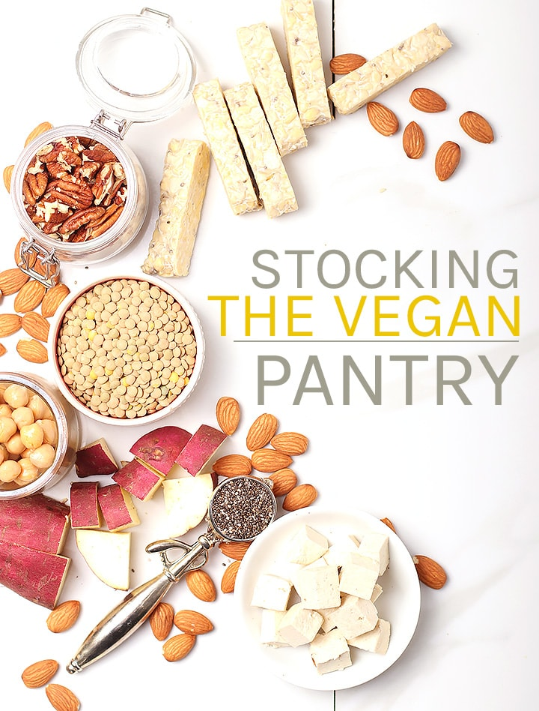

HOW TO STOCK A VEGAN PANTRY
My kitchen is primarily a whole foods kitchen. That means I don’t buy or use much processed foods. That also means I don’t use commercial dairy alternatives, with the exception of milk and butter (primarily for baking). However, I’ve gone through periods during my 13-year journey of veganism where I have really appreciated having those comfort foods around, and so I have added my favorites to this list.

WHERE DO I GET MY GROCERIES?
A lot of people ask me where I get my groceries. I get them all over the place. For produce, plant-based cheese and milk alternatives, and other refrigerated goods, I typically shop at Whole Foods or Trader Joes. They both have great selections of vegan groceries and are always coming out with new products to try.
For most of my non-perishable items, I shop at Thrive Market. Thrive Market is an online marketplace that is on a mission to make healthy living easy and affordable for everyone. Thrive Market has thousands of best-selling organic foods and natural products and they are priced 25-50% lower than traditional retail prices!

CLICK HERE TO USE MY LINK AND YOU’LL GET AN EXTRA 25% OFF YOUR ORDER AND GET A FREE 30-DAY TRIAL TO THRIVE MARKET!

VEGAN PANTRY TABLE OF CONTENTS

Grains & Pasta
Flour
Beans & Legumes
Nuts & Seeds
Jarred and Canned Goods
Fruits and Vegetables
Sweeteners
Superfoods
Spices
Oils & Vinegar
Refrigerated Essentials
Pantry Essentials

GRAINS & PASTA
Grains and pasta provide a ton of protein and fiber and are the perfect base food most of my go-to meals such as stir-fry, curry, and buddha bowls. Overnight oats are also one of my go-to breakfasts. Oats are quick and fast way to get a wholesome, heart-healthy meal that will fuel you up. I have a rotating variety of grains and pasta in my vegan pantry. These are the ones I recommend having on hand.
- brown and white rice
- wild rice
- quinoa
- couscous
- oats – steel cut and old fashioned
- whole wheat pasta
- quinoa pasta
- rice noodles
- soba noodles

FLOUR
If you like baking, then having an array of flours is necessary. While I use all-purpose flour or whole wheat flour for most of my baking, there are times when I want a gluten-free option (hello, GF breakfast cookies) and something like almond meal or quinoa flour does the trick! Chickpea flour is one of my favorite egg replacers and is perfect in this flourless chocolate cake.
- all-purpose flour
- whole wheat flour
- cake flour
- almond meal
- buckwheat
- chickpea flour
- quinoa flour
- 1:1 GF Flour Blend

BEANS & LEGUMES
Beans and legumes are an important part of a healthy plant-based diet. They are a great source of protein and fiber and add so much flavor to any meal. Lentils offer a great whole-food, plant-based alternative to meat (like in this Vegan Meatloaf) and when mixed with rice make a complete protein. Aside from that, chickpeas, when roasted, make a delicious and wholesome snack that I love to have on hand!
- chickpeas
- black beans
- kidney beans
- black-eyed peas
- pinto beans
- red and green lentils
- split peas
- peas

NUTS & SEEDS
Nuts and seeds are an important part of my kitchen. They are some of the most nutrient-dense foods available and are so incredibly versatile. I add them to salads, dinner, use them in desserts, and even egg replacers. Not to mention they are the perfect snack! Nuts and seeds provide a healthy dose of protein, good fats, and tons of nutrients. The nuts and seeds I always have on hand are:
- almonds
- hazelnuts
- peanuts
- cashews
- pecans
- macadamia nuts
- walnuts
- sunflower seeds
- flax seeds
- chia seeds
- pumpkin seeds

JARRED & CANNED GOODS
I have a variety of jarred and canned goods in my pantry. I like to have a handful of canned goods on hand so that I can easily create any pasta or curry dish. And, of course, without sauerkraut how could I make my famous Tempeh Reuben? Coconut milk and apple sauce are nice to have around for baking needs (both are great egg replacers!) and while I prefer dried beans, having an array of canned beans is so nice when you’re short on time.
- coconut milk
- tomatoes – crushed, diced, paste
- beans- black, kidney, pinto, chickpea
- marinara sauce
- pizza sauce
- jackfruit
- curry paste
- vegetable broth
- artichoke hearts
- pickles
- sauerkraut
- olives – black, kalamata, Castellano
- applesauce

FRUITS & VEGETABLES
I am not a huge fan of fruit but I do always have a few fruits and a ton of veggies in my kitchen. With a variety of vegetables, I can easily make big salads for lunch, veggie-packed stir-fries, and buddha bowls, and tofu scrambles every morning. This list evolves slightly, depending on what’s in season. Some of the constant fruits and vegetables I have on hand are:
- bananas
- apples
- avocados
- tomatoes
- lemons and limes
- sweet potatoes
- onions
- zucchini
- cucumber
- broccoli
- bell peppers
- mushrooms
- salad greens
- dark leafy greens

SWEETENERS
Whether or not sugar is vegan is a hotly debated topic. So much so that I wrote a comprehensive guide to vegan sugar which will give you ALL the ins and outs of sugar. While I always have white and brown sugar in my pantry for my decadent chocolate cakes and all my cookie recipes, I often prefer sugar alternatives. Maple syrup is my go-to sugar alternative and is perfect in both savory and sweet recipes. Here are the other sugars I keep in my pantry:
- sugar (brown and white)
- coconut sugar
- powdered sugar
- dates and date sugar
- brown rice syrup
- maple syrup
- raw agave nectar
- monk fruit
- monk fruit

SUPERFOODS
I am a HUGE fan of stocking a kitchen full of superfoods. What is a superfood? It’s any nutrient-rich food that is considered to be beneficial for health and overall well-being. I go into detail about my favorite superfoods, how to use them, and where to buy them here. In short, they are a delicious way to pack on the nutrients by adding them to smoothies, oats, salads, cookies, and more! The superfoods I always have
- hemp hearts
- cacao nibs
- cacao powder
- goji berries
- matcha powder
- chia seeds
- almonds
- ginger
- dark chocolate

SPICES
Having a complete spice rack is an essential part of a well-stocked vegan kitchen. I love this door mount spice rack which allows you to use the spices you choose and arrange them in a way that makes sense to you. The spices that I think every baker and chef should have are:
- Allspice
- Basil
- Bay Leaves
- Cardamom
- Cayenne
- Chili Powder
- Cinnamon
- Cloves
- Coriander
- Cumin
- Curry Powder
- Garlic Powder
- Ginger
- Nutmeg
- Onion Powder
- Oregano
- Paprika
- Black Peppercorns
- Red Pepper Flakes
- Rosemary
- Sage
- Coarse Sea Salt
- Thyme
- Turmeric

OILS & VINEGARS
Having an array of oil and vinegar is an important part of a well-stocked kitchen. I use different oils for different cooking methods. You’ll need several high-heat oils like avocado oil and coconut oil for sautéing vegetables and tofu. Olive oil is good in salad dressing, cakes, and other baked goods. Vinegar serve a variety of purposes and I recommend keeping a couple on hand.
- coconut oil
- avocado oil
- extra virgin olive oil
- sesame oil
- peanut oil
- flaxseed oil
- apple cider vinegar
- balsamic vinegar
- white wine vinegar
- red wine vinegar
- rice vinegar

VEGAN REFRIGERATED ESSENTIALS
My refrigerator is typically full of vegetables, a few important condiments, and some non-dairy alternatives such as milk, yogurt, butter, and cheese. The only kind of non-dairy cheese I buy is Violife. If you haven’t tried it, I HIGHLY recommend it. Aside from that, I always have some tofu and tempeh, salsa, hummus, and a few of my favorites sauces so I can make my favorite stir fries on a whim.
- tempeh
- tofu
- non-dairy milk (soy, almond, cashew, coconut)
- non-dairy yogurt
- vegan butter
- non-dairy cheese
- salsa
- hummus
- miso
- soy sauce
- hoisin sauce
- vegan Worchestire sauce
- condiments (hot sauce, mustard, ketchup, vegan mayo)

VEGAN PANTRY ESSENTIALS
Aside from all the other foods in my pantry, here are a few odds and ends that help me in baking (gotta have those classic chocolate chip cookies), cooking (what’s a tofu scramble without nutritional yeast?) and snacking (because we all love peanut butter popcorn).
- popcorn
- crackers
- nut and seed butter
- chocolate chips
- vanilla extract
- nutritional yeast
- shredded coconut (unsweetened)
- baking powder & soda
- cocoa powder
- cornstarch
- cornmeal

